Принудительная адресация с полным форматом микрокоманды

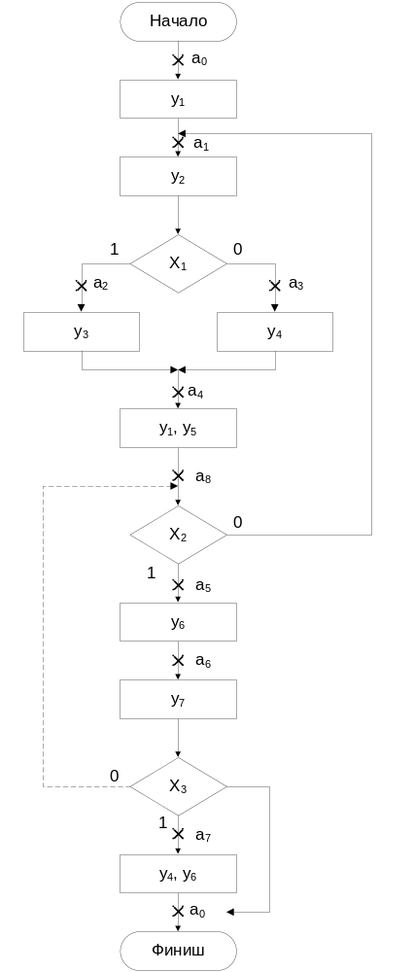
адрес | Y |  |  |  |  |  |  | X |  |  | 1 | 0
адрес | y₁ | y₂ | y₃ | y₄ | y₅ | y₆ | y₇ | X₁ | X₂ | X₃ | 1 | 0
a₀ | 1 | 0 | 0 | 0 | 0 | 0 | 0 | 0 | 0 | 0 | a₁ | a₁
a₁ | 0 | 1 | 0 | 0 | 0 | 0 | 0 | 1 | 0 | 0 | a₂ | a₃
a₂ | 0 | 0 | 1 | 0 | 0 | 0 | 0 | 0 | 0 | 0 | a₄ | a₄
a₃ | 0 | 0 | 0 | 1 | 0 | 0 | 0 | 0 | 0 | 0 | a₄ | a₄
a₄ | 1 | 0 | 0 | 0 | 1 | 0 | 0 | 0 | 1 | 0 | a₅ | a₁
a₅ | 0 | 0 | 0 | 0 | 0 | 1 | 0 | 0 | 0 | 0 | a₆ | a₆
a₆ | 0 | 0 | 0 | 0 | 0 | 0 | 1 | 0 | 0 | 1 | a₇ | a₀
a₇ | 0 | 0 | 0 | 1 | 0 | 1 | 0 | 0 | 0 | 0 | a₀ | a₀
адрес | Y |  |  |  |  |  |  | X |  |  | 1 | 0
адрес | y₁ | y₂ | y₃ | y₄ | y₅ | y₆ | y₇ | X₁ | X₂ | X₃ | 1 | 0
a₀ | 1 | 0 | 0 | 0 | 0 | 0 | 0 | 0 | 0 | 0 | a₁ | a₁
a₁ | 0 | 1 | 0 | 0 | 0 | 0 | 0 | 1 | 0 | 0 | a₂ | a₃
a₂ | 0 | 0 | 1 | 0 | 0 | 0 | 0 | 0 | 0 | 0 | a₄ | a₄
a₃ | 0 | 0 | 0 | 1 | 0 | 0 | 0 | 0 | 0 | 0 | a₄ | a₄
a₄ | 1 | 0 | 0 | 0 | 1 | 0 | 0 | 0 | 1 | 0 | a₅ | a₁
a₅ | 0 | 0 | 0 | 0 | 0 | 1 | 0 | 0 | 0 | 0 | a₆ | a₆
a₆ | 0 | 0 | 0 | 0 | 0 | 0 | 1 | 0 | 0 | 1 | a₇ | a₈
a₇ | 0 | 0 | 0 | 1 | 0 | 1 | 0 | 0 | 0 | 0 | a₀ | a₀
a₈ | 0 | 0 | 0 | 0 | 0 | 0 | 0 | 0 | 1 | 0 | a₅ | a₁

Принудительная адресация с сокращённым форматом микрокоманды

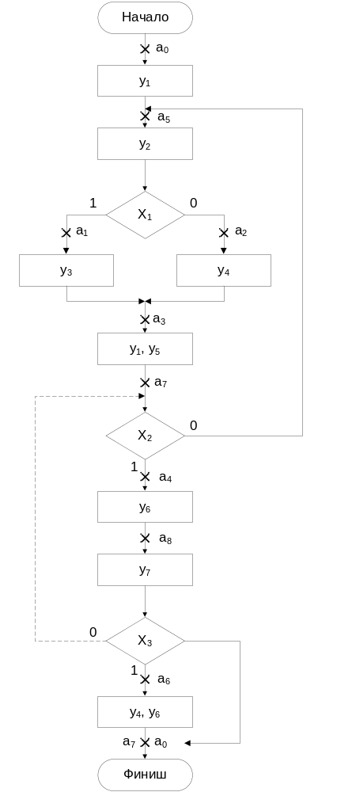
адрес | Y |  |  |  |  |  |  | X |  |  | 1
адрес | y₁ | y₂ | y₃ | y₄ | y₅ | y₆ | y₇ | X₁ | X₂ | X₃ | 1
a₀ | 1 | 0 | 0 | 0 | 0 | 0 | 0 | 0 | 0 | 0 | a₅
a₁ | 0 | 0 | 1 | 0 | 0 | 0 | 0 | 0 | 0 | 0 | a₃
a₂ | 0 | 0 | 0 | 1 | 0 | 0 | 0 | 0 | 0 | 0 | a₃
a₃ | 1 | 0 | 0 | 0 | 1 | 0 | 0 | 0 | 1 | 0 | a₄
a₄ | 0 | 0 | 0 | 0 | 0 | 1 | 0 | 0 | 0 | 0 | а₈
a₅ | 0 | 1 | 0 | 0 | 0 | 0 | 0 | 1 | 0 | 0 | a₁
a₆ | 0 | 0 | 0 | 1 | 0 | 1 | 0 | 0 | 0 | 0 | a₀
a₇ | 0 | 0 | 0 | 0 | 0 | 0 | 0 | 0 | 0 | 0 | a₀
a₈ | 0 | 0 | 0 | 0 | 0 | 0 | 1 | 0 | 0 | 1 | a₆
адрес | Y |  |  |  |  |  |  | X |  |  | 1
адрес | y₁ | y₂ | y₃ | y₄ | y₅ | y₆ | y₇ | X₁ | X₂ | X₃ | 1
a₀ | 1 | 0 | 0 | 0 | 0 | 0 | 0 | 0 | 0 | 0 | a₅
a₁ | 0 | 0 | 1 | 0 | 0 | 0 | 0 | 0 | 0 | 0 | a₃
a₂ | 0 | 0 | 0 | 1 | 0 | 0 | 0 | 0 | 0 | 0 | a₃
a₃ | 1 | 0 | 0 | 0 | 1 | 0 | 0 | 0 | 1 | 0 | a₄
a₄ | 0 | 0 | 0 | 0 | 0 | 1 | 0 | 0 | 0 | 0 | а₈
a₅ | 0 | 1 | 0 | 0 | 0 | 0 | 0 | 1 | 0 | 0 | a₁
a₆ | 0 | 0 | 0 | 1 | 0 | 1 | 0 | 0 | 0 | 0 | a₀
a₇ | 0 | 0 | 0 | 0 | 0 | 0 | 0 | 0 | 1 | 0 | a₄
a₈ | 0 | 0 | 0 | 0 | 0 | 0 | 1 | 0 | 0 | 1 | a₆

Естественная адресация

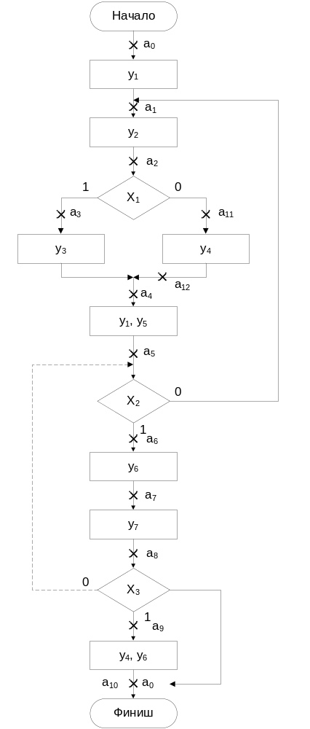
адрес | T | X |  |  |  | A
адрес | T | x₁ | x₂ | x₃
адрес | T | Y
адрес | T | y₁ | y₂ | y₃ | y₄ |  | y₅ | y₆ | y₇
a₀ | 0 | 1 | 0 | 0 | 0 |  | 0 | 0 | 0
a₁ | 0 | 0 | 1 | 0 | 0 |  | 0 | 0 | 0
a₂ | 1 | 1 | 0 | 0 | a₁₁
a₃ | 0 | 0 | 0 | 1 | 0 |  | 0 | 0 | 0
a₄ | 0 | 1 | 0 | 0 | 0 |  | 1 | 0 | 0
a₅ | 1 | 0 | 1 | 0 | a₁
a₆ | 0 | 0 | 0 | 0 | 0 |  | 0 | 1 | 0
a₇ | 0 | 0 | 0 | 0 | 0 |  | 0 | 0 | 1
a₈ | 1 | 0 | 0 | 1 | a₀
a₉ | 0 | 0 | 0 | 0 | 1 |  | 0 | 0 | 0
a₁₀ | 1 | 0 | 0 | 0 | a₀
a₁₁ | 0 | 0 | 0 | 0 | 1 |  | 0 | 0 | 0
a₁₂ | 1 | 0 | 0 | 0 | a₄
адрес | T | X |  |  |  | A
адрес | T | x₁ | x₂ | x₃
адрес | T | Y
адрес | T | y₁ | y₂ | y₃ | y₄ |  | y₅ | y₆ | y₇
a₀ | 0 | 1 | 0 | 0 | 0 |  | 0 | 0 | 0
a₁ | 0 | 0 | 1 | 0 | 0 |  | 0 | 0 | 0
a₂ | 1 | 1 | 0 | 0 | a₁₁
a₃ | 0 | 0 | 0 | 1 | 0 |  | 0 | 0 | 0
a₄ | 0 | 1 | 0 | 0 | 0 |  | 1 | 0 | 0
a₅ | 1 | 0 | 1 | 0 | a₁
a₆ | 0 | 0 | 0 | 0 | 0 |  | 0 | 1 | 0
a₇ | 0 | 0 | 0 | 0 | 0 |  | 0 | 0 | 1
a₈ | 1 | 0 | 0 | 1 | a₅
a₉ | 0 | 0 | 0 | 0 | 1 |  | 0 | 0 | 0
a₁₀ | 1 | 0 | 0 | 0 | a₀
a₁₁ | 0 | 0 | 0 | 0 | 1 |  | 0 | 0 | 0
a₁₂ | 1 | 0 | 0 | 0 | a₄

